Link to GitHub Repo: <https://github.com/ttaylo56/IFT-458-M1-Assignment>

Screenshots:

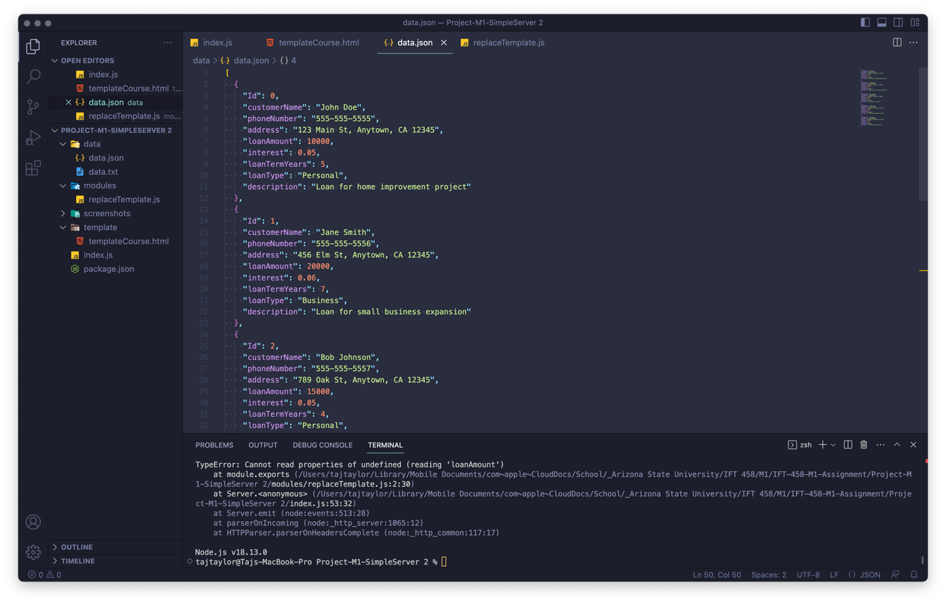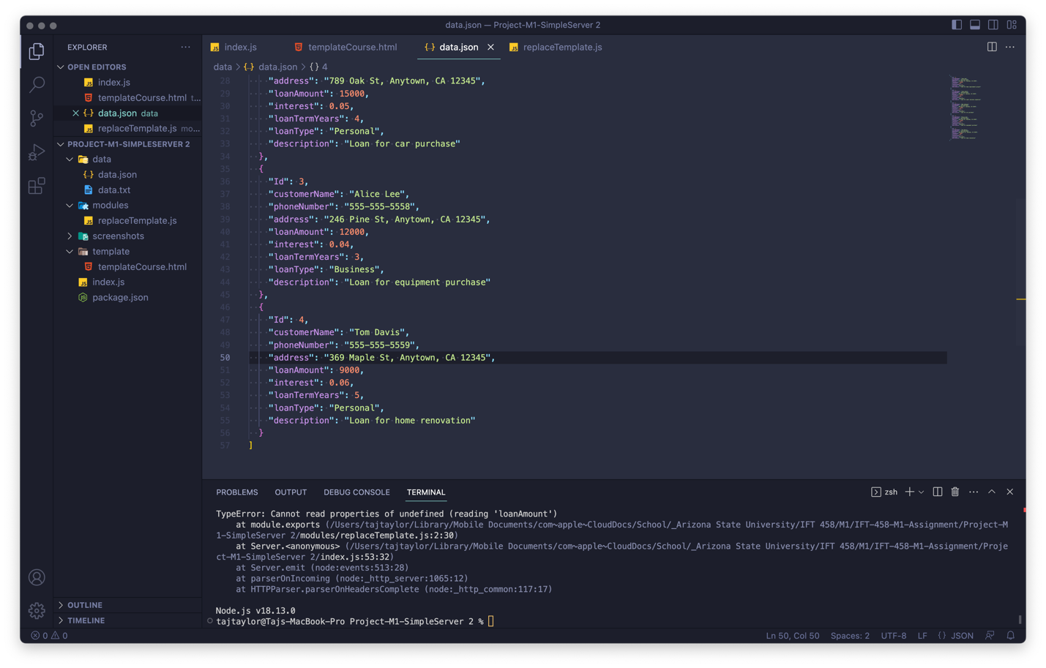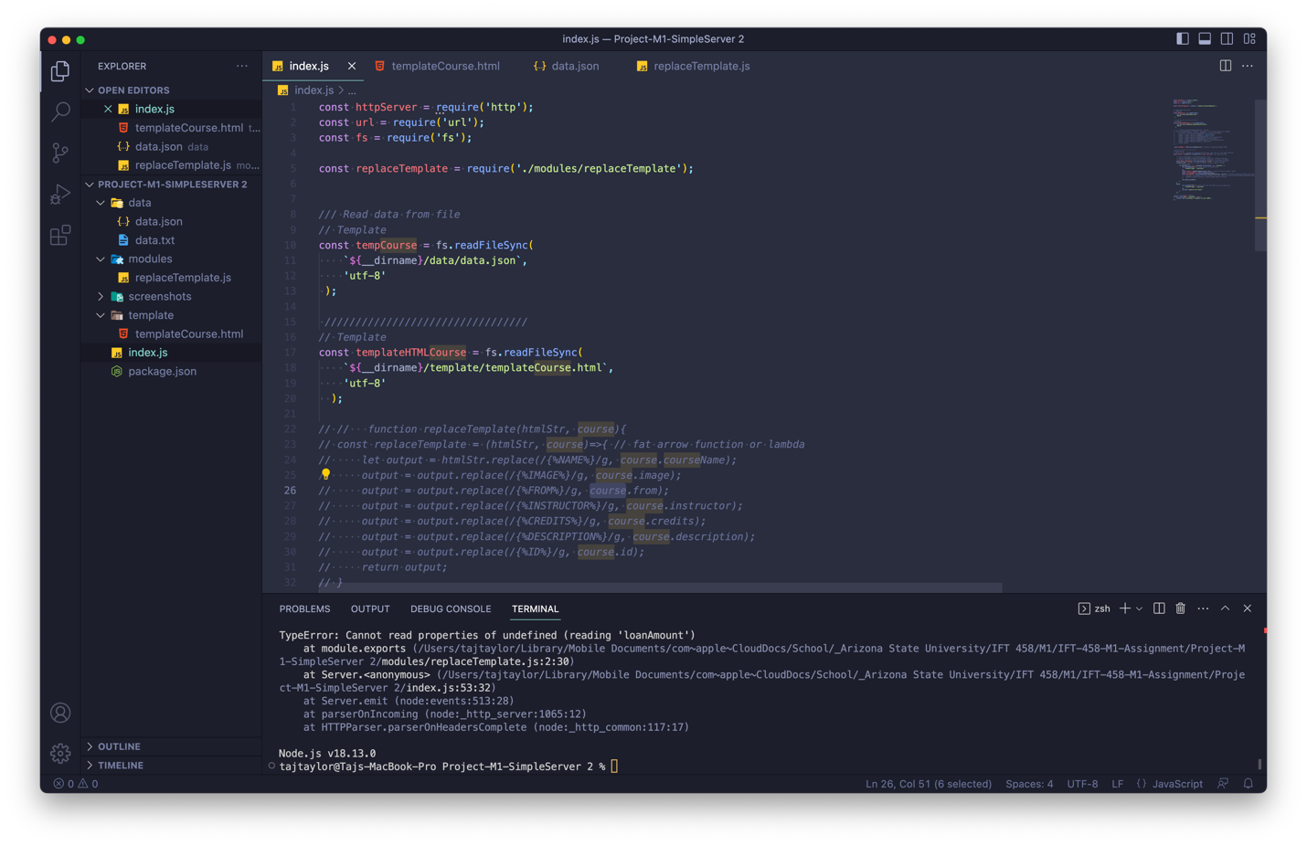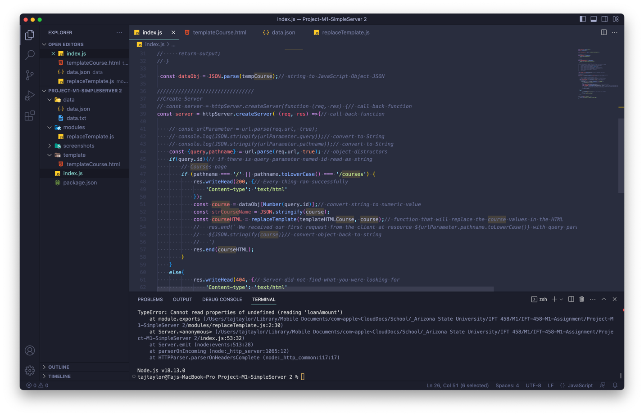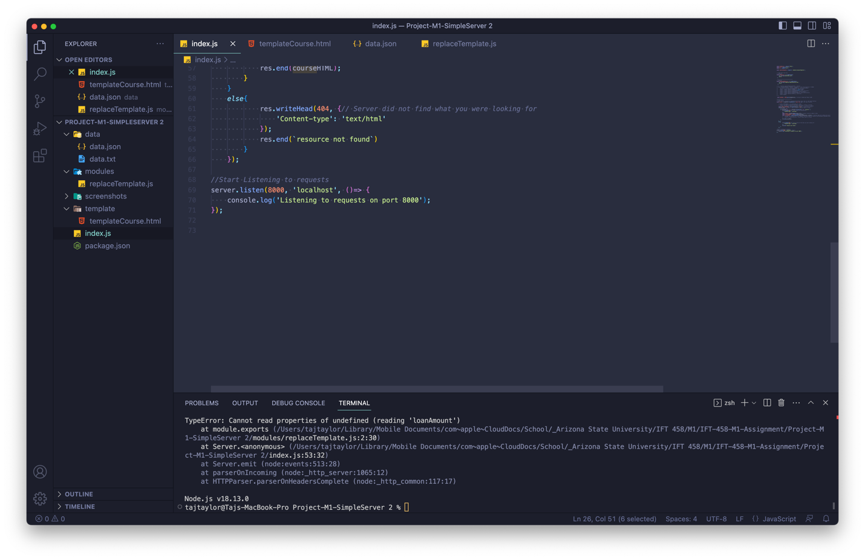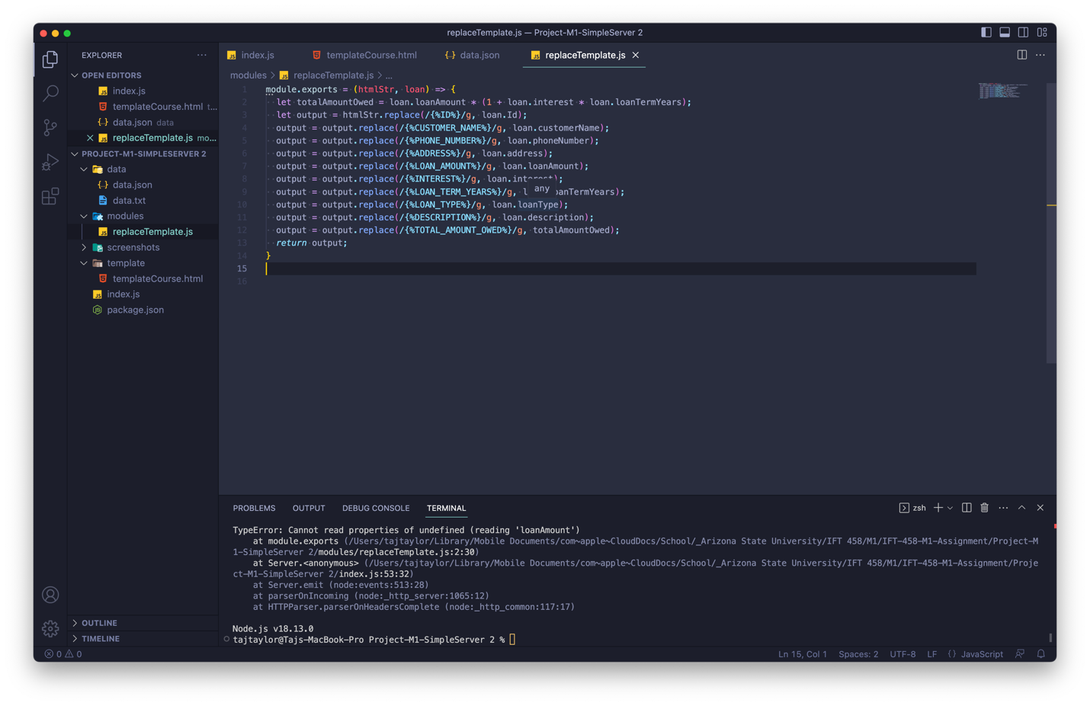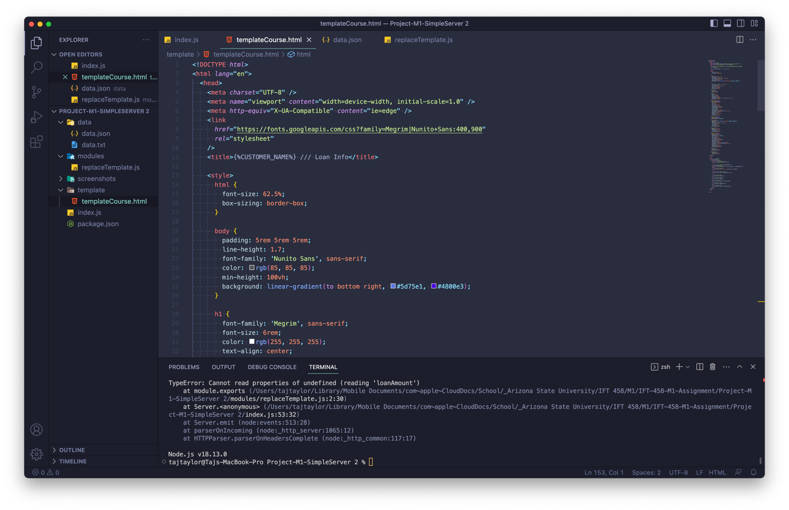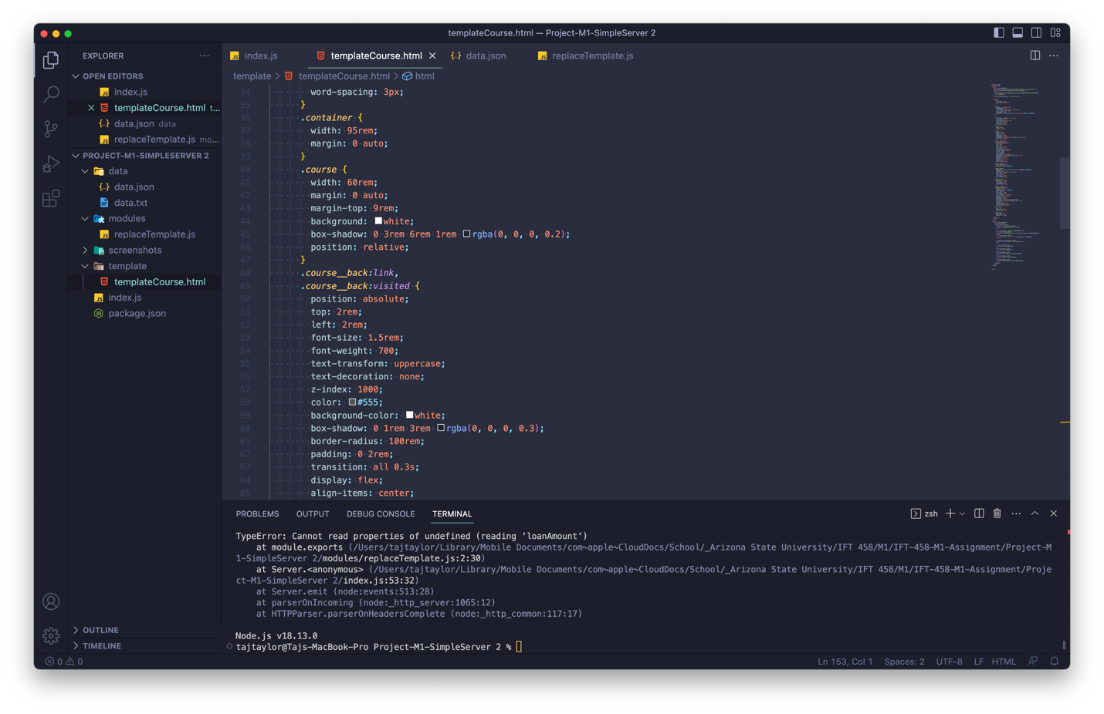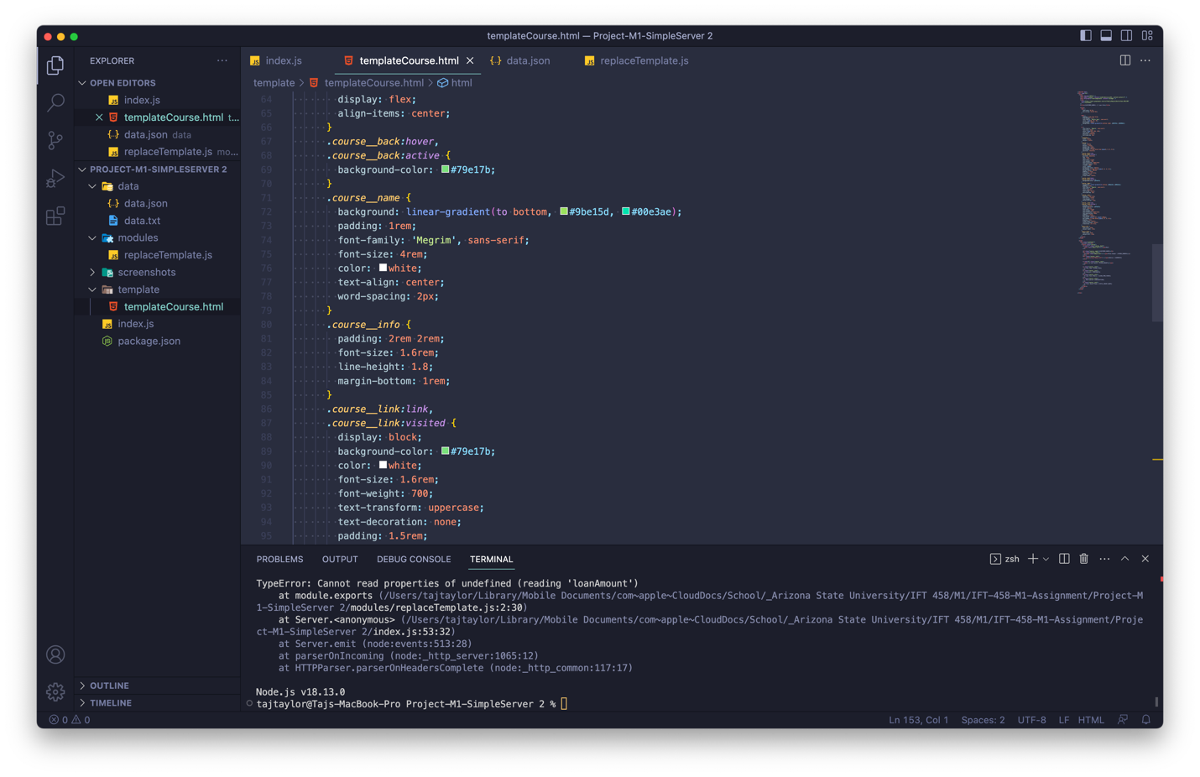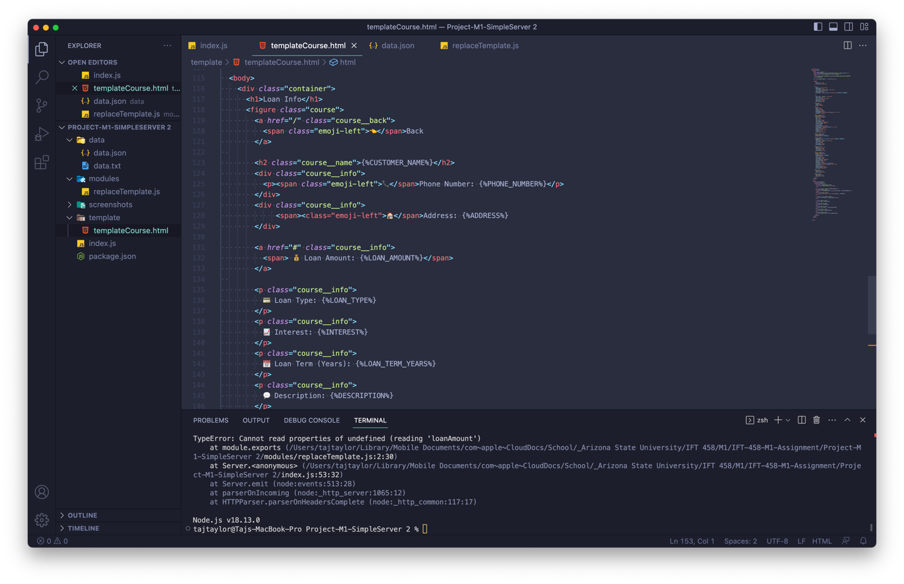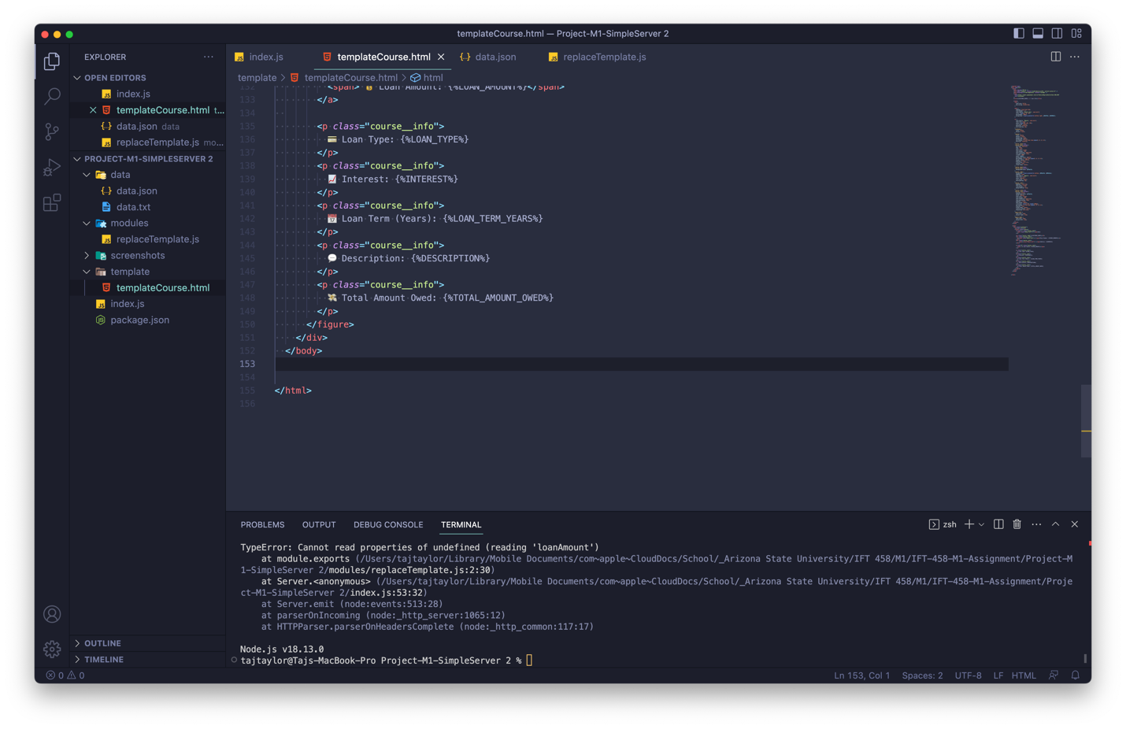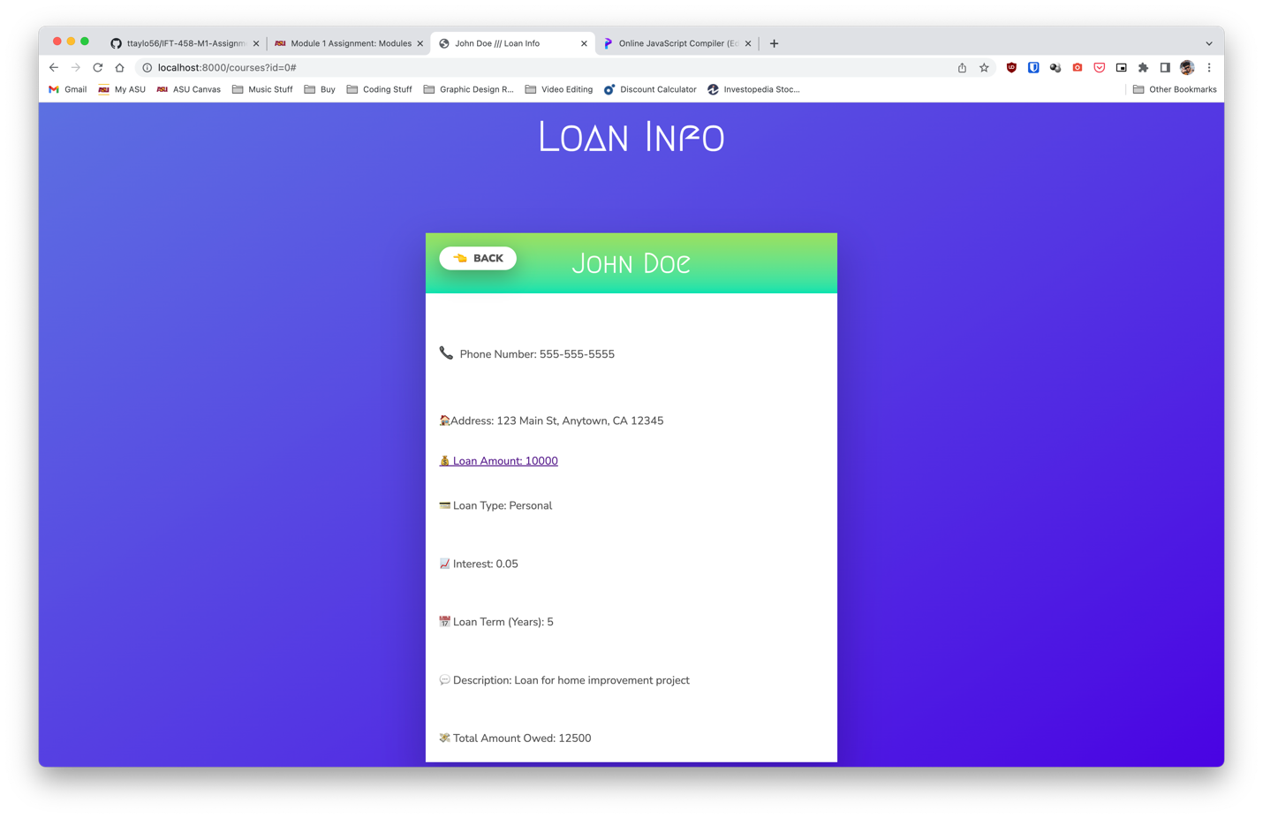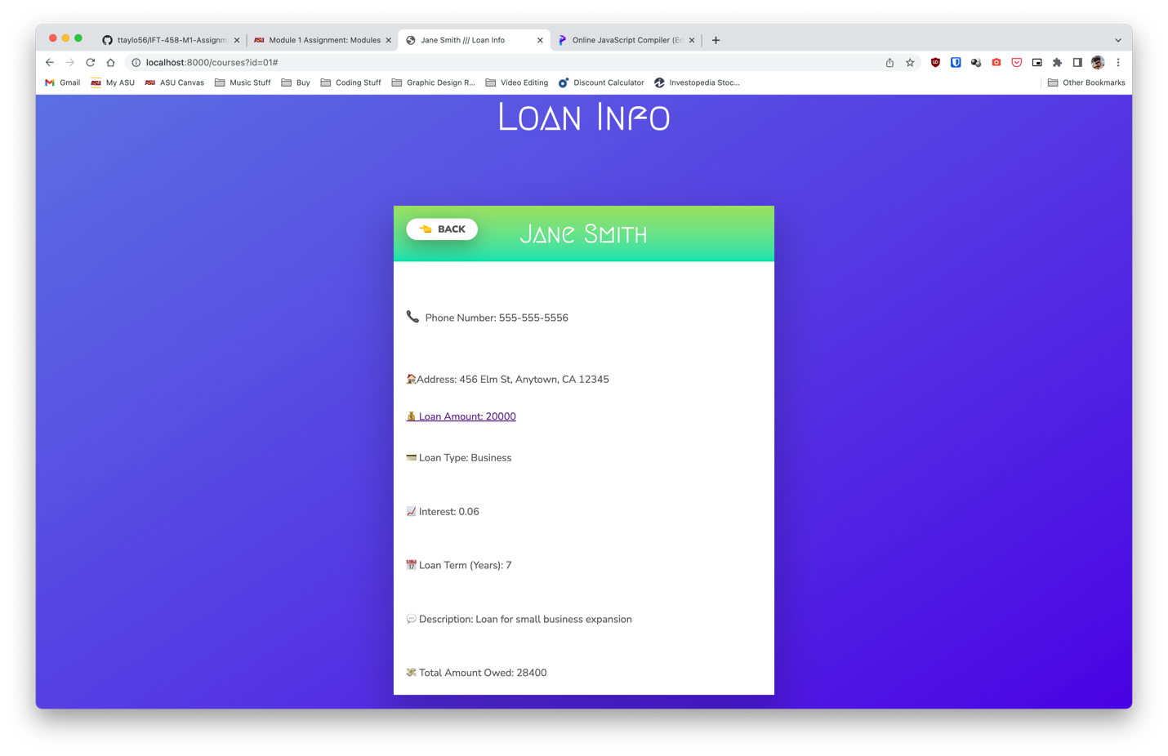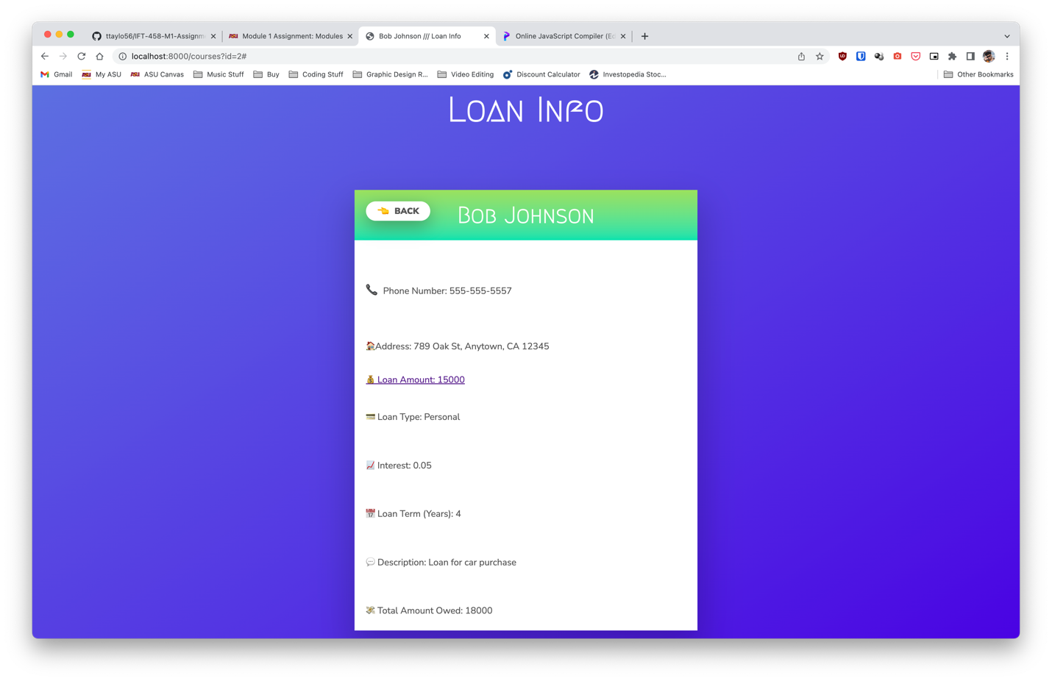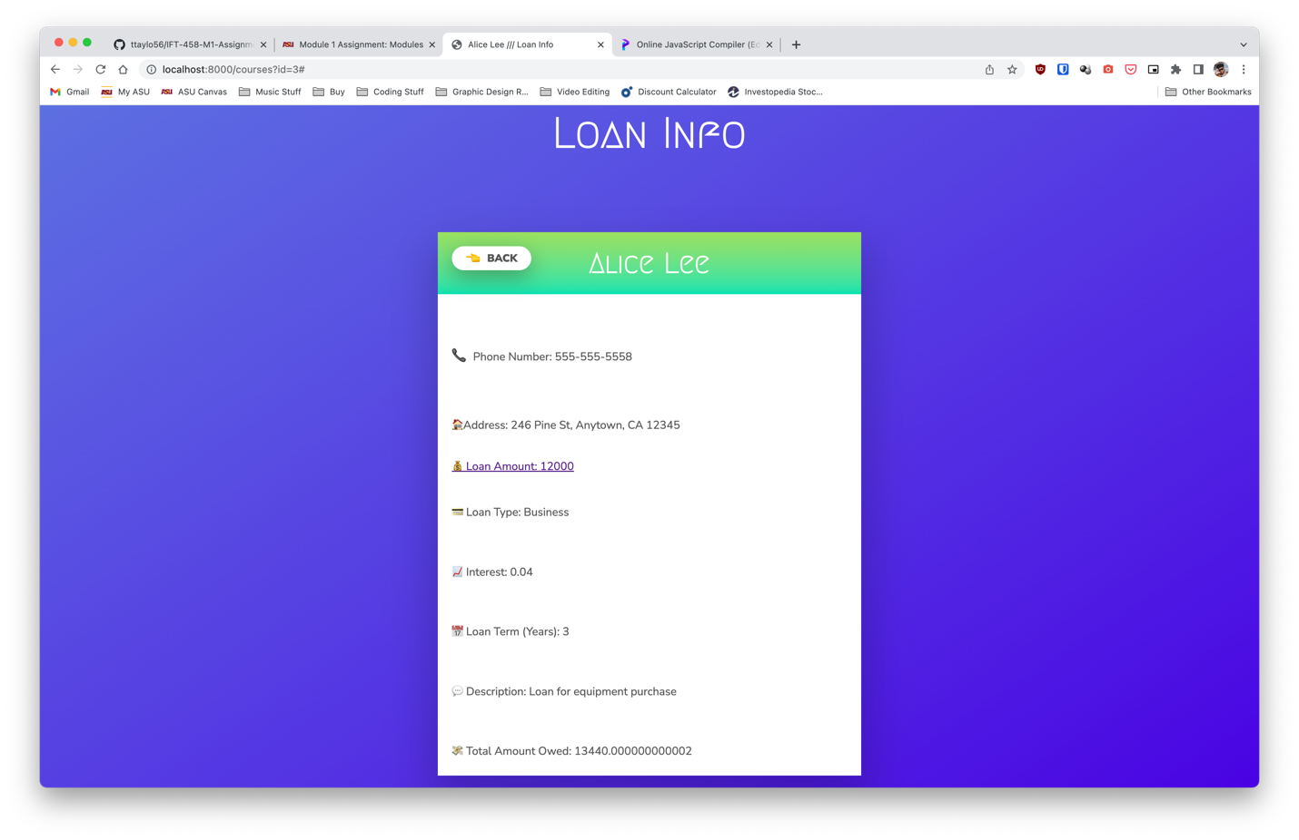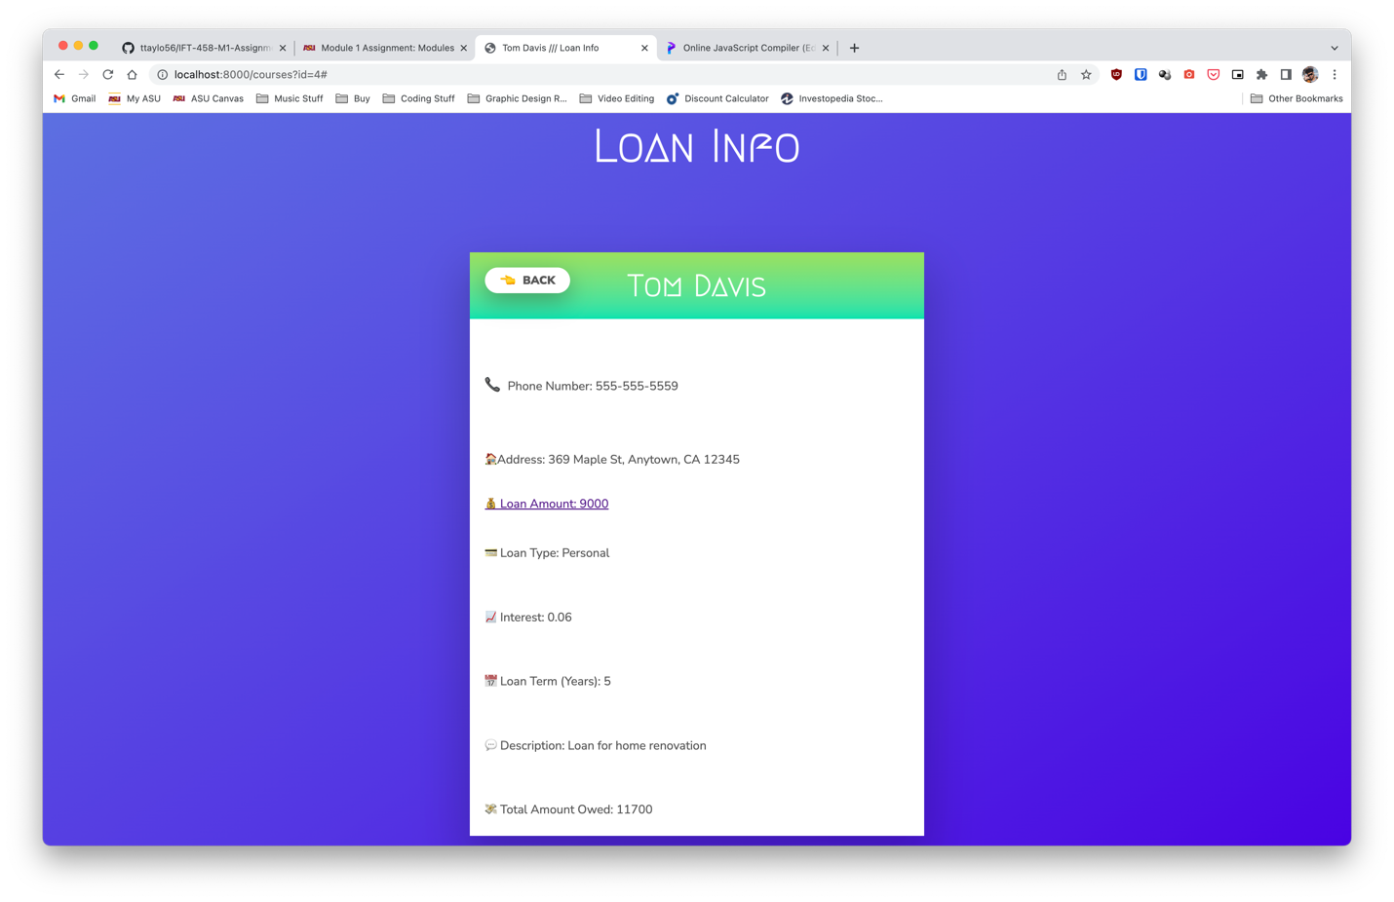

Common HTTP Status Codes:

1xx - Informational: The request was received, and the server is continuing to process it.

2xx - Success: The request was successfully received, understood, and accepted.

* 200 OK: The most common status code, indicating a successful request.
* 201 Created: Indicates that a resource was successfully created in response to a POST request.
* 204 No Content: Indicates that the request was successful but there is no representation to return.

3xx - Redirection: Further action needs to be taken by the user agent to fulfill the request.

* 301 Moved Permanently: Indicates that the requested resource has been permanently moved to a new URL.
* 302 Found: Indicates that the requested resource temporarily resides at a different URL.
* 304 Not Modified: Indicates that the requested resource has not been modified since the client last requested it.

4xx - Client Error: The request contains bad syntax or cannot be fulfilled by the server.

* 400 Bad Request: Indicates that the request was malformed or invalid.
* 401 Unauthorized: Indicates that authentication failed or the user does not have permission to access the resource.
* 403 Forbidden: Indicates that the server refuses to fulfill the request.
* 404 Not Found: Indicates that the requested resource could not be found on the server.

5xx - Server Error: The server failed to fulfill an apparently valid request.

* 500 Internal Server Error: A generic error message, given when an unexpected condition was encountered by the server and no more specific message is suitable.
* 503 Service Unavailable: Indicates that the server is temporarily unable to handle the request, usually due to maintenance or resource constraints.

Common HTTP Response Headers:

* Cache-Control: Specifies the caching directives for the response
* Connection: Specifies the type of connection (keep-alive or close)
* Content-Encoding: Specifies the encoding of the response content
* Content-Language: Specifies the language of the response content
* Content-Length: Specifies the size of the response content in bytes
* Content-Type: Specifies the MIME type of the response content
* Date: Specifies the date and time the response was generated
* ETag: Specifies a unique identifier for the response content
* Expires: Specifies the date and time after which the response content is considered stale
* Location: Specifies the URL to redirect a client to
* Server: Specifies the software and version used to handle the request
* Set-Cookie: Specifies a cookie to set for the client
* Vary: Specifies the criteria for determining cache-ability of the response
* X-Powered-By: Specifies the technology used to generate the response